
Update date, xx xxxx

Visa Debit Card Fraud Investigation
PROCESS

October 5, 2026

Document Tracking and Control Table

Policy Owner | Stacey McKay - Fraud Mitigation Manager, Risk Department
Approval Date | TBC
Version | 001
Access Level | Fraud Prevention Department
Policy Author | Stacey McKay - Fraud Mitigation Manager, Risk Department
Subject Matter Expert(s) | Stacey McKay - Fraud Mitigation Manager, Risk Department
Last Full Review Date | TBC
Update Date (changes were made but a full review was not necessarily conducted) | TBC
Review Frequency Requirement | Annually
Changes made | Refer to Version History
Stakeholders Impacted | Risk

Table of Contents
​​
​​
1 Purpose 2
2 Scope 2
3 Roles and Systems 2
4 Member-Reported Visa Debit Card Fraud (referred by the Growth Team) – Process Flow and Procedure 4
4.1 Process Flow 4
4.2 Procedure 4
4.2.1 Review Referral and Available Information 4
4.2.2 Conduct Investigation 5
4.2.3 Determine and Record Investigation Outcome & Report Confirmed Fraud to ICICI 6
4.2.4 Complete Updates in eDetect and Create Case in the Fraud Tracking Worksheet 6
5 eDetect Fraud Alert Referral – Process Flow and Procedure 7
5.1 Process Flow 7
5.2 Procedure 7
6 Visa Debit Card Fraud Types 7
Appendices 8
Appendix A – Accessing eDetect 8
Appendix B – Accessing eAuthenticate 8
Appendix C – ICICI Fraud Reporting Guide 9
Version History 9

​

​

Purpose
The Visa Debit Card Fraud Investigation Process guides the Fraud Prevention Team in investigating suspected Visa Debit Card fraud. It sets out an approach for reviewing fraud referrals and alerts, conducting investigations, determining and documenting outcomes, and completing treatment actions and required reporting. It also covers the roles, systems, and responsibilities involved, the process flows and detailed investigation procedures, and the applicable Visa Debit Card Fraud typologies, with reference material in the appendices to support the end-to-end fraud investigation lifecycle.

Scope
This procedure applies to Fraud Prevention Team members authorized to conduct Visa Debit Card Fraud investigations. It is applicable to investigations initiated through the following channels:
- Member-Reported Fraud (referred by the Growth Team): occurs when Growth (Branch or Contact Centre) submits a completed Fraud Intake Form (FIF) to the Fraud Prevention Team for investigation and decisioning.
- eDetect Fraud Alert: occurs when eDetect (Everlink solution) generates an alert on suspicious Visa Debit card activity that requires review by the Fraud Prevention Team.

Roles and Systems
The following roles and systems support various activities within the Visa Debit Card Fraud Investigation Process.
Role / System | Responsibility
Fraud Prevention Department | Fraud Management / Fraud Specialists provide centralized expertise and coordination to support consistent fraud detection, escalation, investigation, response, recovery, and reporting practices across the organization. They are responsible for leading or coordinating fraud investigations and case management activities, supporting appropriate evidence and documentation practices, and enabling effective cross-functional coordination and governance visibility for significant fraud risks, trends, and incidents.  Key responsibilities may include:  - conducting or coordinating fraud investigations and case management activities,  - maintaining case documentation and supporting appropriate evidence handling practices,  - coordinating escalation, response, containment, and recovery activities with relevant operational and support functions  - supporting the review and management of fraud-related disputes.  - supporting reimbursement and remediation activities in accordance with established guidelines and approvals,  - monitoring fraud trends, emerging risks, and typologies to inform detection and control improvement opportunities,  - supporting fraud reporting, analytics, and governance visibility into material incidents and trends,  - providing operational guidance and input into training and awareness materials,  - coordinating with external parties (e.g., law enforcement, insurers, payment networks) where appropriate.
Growth Team | Front-line contact centre and branch staff who maintain contact with members, receive the member's dispute claim, verify the cardholder and impacted transaction(s), records dispute details. Where required, they perform initial account security actions, such as blocking and reissuing the card.
eDetect | Fraud monitoring solution provided by Everlink, used to monitor Visa Debit transaction activity, generate fraud alerts based on configured rules and models (including eScore), for Fraud Prevention Department review, investigation, and decisioning.
eAuthenticate | Authentication portal used to review Visa Secure (3-D Secure) authentication results and related transaction details for applicable Visa Debit transactions.
DNA | Beem's core banking system used to review member and account information and apply card or account restrictions.
CRM (Dynamics 365) | System of record used to create and track dispute cases and trigger both the ATM/POS trace (non-fraud) and Fraud Intake Form (FIF) (fraud) workflows.
ICICI Bank | ICICI Bank is a direct member of Visa and sponsors Beem's Visa Debit program. It provides Beem with the Bank Identification Number (BIN) used to issue Visa Debit cards. Because Beem issues under ICICI's BIN sponsorship, ICICI remains accountable to Visa for the program. Within this framework, ICICI requires Beem to report suspected and confirmed fraud incidents.

Member-Reported Visa Debit Card Fraud (referred by the Growth Team) – Process Flow and Procedure

4.1 Process Flow
The visual below provides the end-to-end investigation process for cases related to Visa Debit Card Fraud that has been referred to the Fraud Prevention Department.
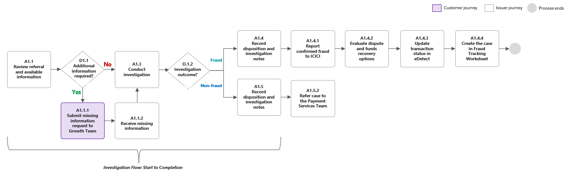

4.2 Procedure
The following procedure provides a step-by-step outline of the activities performed by an assigned Fraud Specialist as part of the end-to-end investigation process.

4.2.1 Review Referral and Available Information
ID Process Flow Reference (A1.1, D.1.1, A1.1.1, A1.1.2)
Upon receipt of a member-reported fraud (referred by the Growth Team), the assigned Fraud Specialist, must review the referral and information provided to determine whether sufficient information is available to proceed with the investigation.
The Fraud Specialist should:
- Open assigned CRM case and review the FIF to determine whether the referral involves suspected Visa Debit Card Fraud.
- If the FIF identifies, Identity Theft, Scams, or Familial Fraud, check whether the incident includes unauthorized Visa Debit card transactions; the outcome of this check determines whether to proceed with the Visa Debit Card Fraud investigation:
  - If yes, continue to Step 3
  - If no, refer to <link>
- Verify that the following information is available for review across relevant sources, including but not limited to:
  - Member and account information (suggested source: FIF and DNA)
  - Date the suspected fraudulent activity was reported (suggested source: FIF)
  - Red flags noted by Growth during member interaction (suggested source: FIF)
  - Fraud incident type, and the respective details (suggested source: FIF)
  - Transaction details (suggested source: FIF,DNA, eDetect)
  - Authentication results (suggested source: eDetect and eAuthenticate)
- Determine whether there is sufficient information available to conduct the investigation
  - If the information is complete, proceed to Section 4.2.2- Conduct Investigation.
  - If information is incomplete, request the additional information from the Growth team via email. Once sufficient information is received, proceed to Section 4.2.2- Conduct Investigation.

4.2.2 Conduct Investigation
ID Process Flow Reference (A1.3)
The Fraud Specialist should:
- Use the Investigation Matrix below as a guide to review the available information and determine whether it indicates fraud
# | Review Area | Specific Data Elements | Fraud Indicators
1. | Transaction Data (suggested source: FIF, DNA, eDetect) | - Date of transaction  - Transaction Amount  - Merchant information  - Transaction channel | - Transaction (s) fall outside the member's normal spending pattern, merchant category, location or time of day
2. | Member’s Account Activity (suggested source: DNA) | - Recent card issuance or reissuance  - PIN changes or resets  - Failed PIN attempts  - Recent digital wallet provisioning | - Activity was not requested, performed, or authorized by the member
3. | Member History & Dispute Pattern  (suggested source: DNA) | - Prior disputes on file | - 3+ disputes within a rolling 12-month period
4. | Authentication Data (suggested source: eAuthenticate, eDetect) | - Authentication details (e.g., risk score)  - Authentication Status (Card holder Cancelled)  - Device data (e.g., IP address, IP country/region, device ID)  - Raw message (e.g., cardholder name) | - IP address or device not seen on the member's previous history  - IP location doesn't match where the member lives or works  - Cardholder name or email doesn't match member records

- Capture investigation notes and findings in CRM FIF case

4.2.3 Determine and Record Investigation Outcome & Report Confirmed Fraud to ICICI
ID Process Flow Reference (D1.2, A1.4, A1.4.1, A1.4.2, A1.5, A1.5.1, A1.5.2)
The Fraud Specialist must determine the investigation outcome based on the totality of evidence identified during the investigation.
The Fraud Specialist should:
- Determine the investigation outcome.
- If fraud is confirmed:
  - Identify the applicable Visa Debit Card Fraud typology (refer to Section 6)
  - Submit confirmed fraud report to ICICI
  - Proceed with the Dispute Management Process <link> to evaluate dispute and funds recovery options.
- If fraud is NOT confirmed:
  - Remove the applicable restrictions (i.e., unblock the card)
  - Refer the case to the Payment Services Team following the Dispute Management Process. <link>
- Record the final decision and fraud typology in CRM.

4.2.4 Complete Updates in eDetect and Create Case in the Fraud Tracking Worksheet
ID Process Flow Reference (A1.4.3, A1.4.4)
The Fraud Specialist must complete required system updates in both eDetect and the Fraud Tracking Worksheet.
The Fraud Specialist should:
- Complete required updates to the relevant systems.
- For eDetect:
  - Manually update the status of the transaction in eDetect
- Select the Visa Debit Card Fraud Type as determined in Section 4.2.3, Step 2.
- For Fraud Tracking Worksheet:
- Manually create the case in the Fraud Tracking Worksheet and populate all mandatory fields <link>.

eDetect Fraud Alert Referral – Process Flow and Procedure

5.1 Process Flow
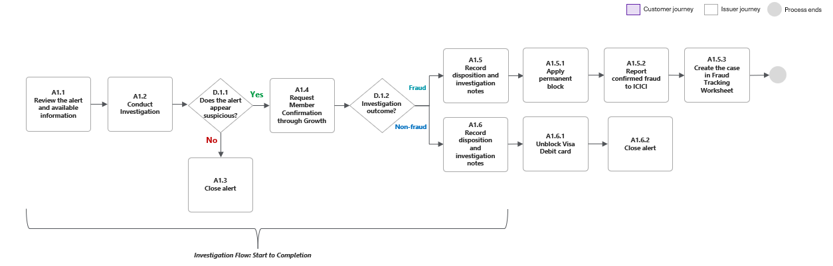

5.2 Procedure
[Placeholder] to be filled out once eDetect document is received.

Visa Debit Card Fraud Types
Visa Debit Card Fraud refers to any fraud involving a member’s Visa Debit card and related transactions. The following section outlines common Visa Debit Card Fraud typologies that may impact Beem, grouped into two categories: 3rd-party fraud and 1st-party fraud.
Third- Party Fraud
Occurs when someone other than the cardholder uses the member's Visa Debit card or card details without authorization.

Visa Debit Card Fraud Type | Description
Card-Not-Present (CNP) Fraud | A Visa Debit card is used without authorization for a transaction where the physical card is not present.
Card-Present (CP) Fraud | A Visa Debit card is used without authorization for a transaction where the physical card is present.
Application Fraud | A Visa Debit Card is obtained using false or stolen information and subsequently used to conduct unauthorized transactions.
Counterfeit Card Fraud | A counterfeit Visa Debit card is created using compromised card information and used to conduct unauthorized transactions.
Never Received Issue | A newly issued or replacement Visa Debit card is intercepted before it is received by the member and subsequently used to conduct unauthorized transactions.
Lost or Stolen Card Fraud | A Visa Debit card is used without authorization after it has been lost or stolen.
Digital Wallet Fraud | A Visa Debit card is added to a digital wallet without the cardholder’s authorization and then used to conduct an unauthorized transaction.
Scams | A Visa Debit card is used as part of a scam in which a member is deceived through impersonation or other fraudulent means into providing card information or authorizing a transaction that benefits a fraudster.

First-Party Fraud
Occurs when the cardholder, makes or authorizes a Visa Debit transaction and then misrepresents it for financial gain.

Fraud Typology | Description
Refund/Dispute Abuse – Individual | A Visa Debit card transaction is authorized by the cardholder to submit a false claim to obtain a refund/reimbursement
Refund/Dispute Abuse – Collusive | A Visa Debit card transaction is authorized by the cardholder, who is acting with another party to submit a false claim to obtain a refund/reimbursement

Appendices

Appendix A – Accessing eDetect
[Placeholder] to be completed upon receipt of eDetect documentation.

Appendix B – Accessing eAuthenticate
eAuthenticate is a tool that provides visibility to authentication requests sent by participating 3D-Secure merchants. It is designed to help Issuers gain further insight into who is initiating card not present transactions. Data availability is based on what merchants collect from end users, and what they pass on for authentication. To access eAuthenticate, please follow the outlined steps:
- Login to VCAS ( https://www.visaonline.com/login/) using the provided link and your assigned credentials.
- Depending on your assigned role access level, there will be two modules available 3DS Reporting Suite and Customer Service. Launch the desired module.
- 3DS Reporting Suite is Customer Service portal is intended to be used by front line staff to help them answer cardholder inquiries, facilitate purchases in case of false positive declines, and secure compromised cards.
- 3DS Reporting Suite is used to search for similar transactions, reviewing historical transaction details, and marking fraudulent activity.
For navigating through the tool and other detailed guidance, please refer directly to the eAuthenticate document.

Appendix C – ICICI Fraud Reporting Guide
[Placeholder] pending completion.

Version History
DATE | VERSION | CHANGE
September 28, 2026 | 001 | Initial Version Created

Refer to Appendix A for more details on eDetect
Refer to Appendix B for more details on eAuthenticate

